PART-A
1. Check if a number belongs to the Fibonacci Sequence.
n = int(input("Enter a number: "))
a,b = 0,1
while b < n:
a, b =b,a+b
print("Yes" if b == n else "No")
Output :
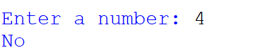

2.Solve Quadratic Equations
import cmath
a = int(input("Enter A: "))
b = int(input("Enter B: "))
c = int(input("Enter C: "))

d=(b ** 2) -(4*a*c)

r1 =(-b-cmath.sqrt(d)) / (2*a)
r2 =(-b+cmath.sqrt(d)) / (2*a)

print("The Solution are {0} and {1} ".format(r1,r2))
Output : 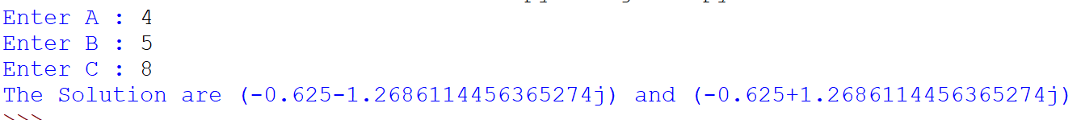
3. Find the sum of n natural numbers
n = int(input("Enter A Number :"))

if(n<0):
print("Enter a Possitive Number ")
else:
sum =0
while(n>0):
sum =sum+n # OR sum +=n
n=n-1 # OR num-=1
print("The Sum is ",sum)

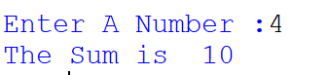
4. Display Multiplication Tables
n = int(input("Enter the Number"))
for i in range(1,11):
print(n,"X",i,"=",n*i)

Output ;
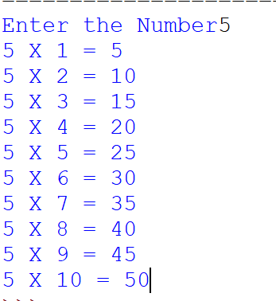
5. Check if a given number is a Prime Number or not

n = int(input("Enter Any Number :"))

if n>1:
for i in range (2,n):
if(n % i) == 0:
print(n,"Is not a Prime Number")
break
else:
print(n,"Is a prime Number")
break
else:
print(n,"Is not a Prime Number")

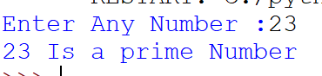

6. Implement a sequential search

arr = [3,5,2,1,8,7]
print(arr)
n = int(input("Enter a Number form the List : "))

for i in range(len(arr)):
if arr[i] == n:
print(f"The Target Number {n} was found at Index {i}")
break
else:
print(f"The Target number {n} was not found in the list")

Output :

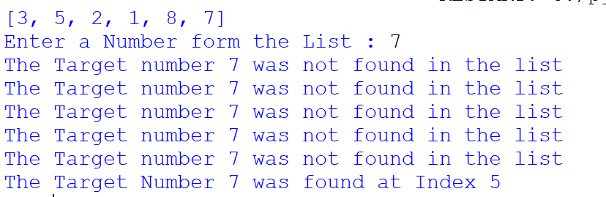

7. Explore string functions
s = "Hello World !"
print(len(s))
print(s.lower())
print(s.upper())
print(s.replace("Hello","Hi"))
name = "Arshad"
print(name.strip())
s2 = "Hello , World !"
print(s2.split(" , "))

Output :

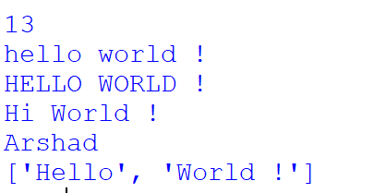

8.Implement of Stack

s = []
s.append("a")
s.append("b")
s.append("c")
print("Current Stack")
print(s)
print("POPing The elements form stack")
print(s.pop())
print(s.pop())
print(s.pop())

print("After the poping all 3 ")
print(s)

Output:
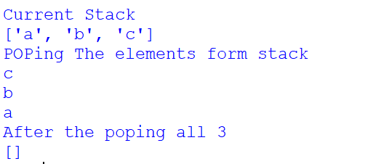

PART B
- Read and write into a file

file = open("arshad.txt","w")
file.write("Hi Friends, I am Your CR")
file = open("arshad.txt","r")
file_output = file.read()
file.close()

print(file_output)

Output:

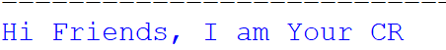

- Demonstrate usage of basic regular expression

import re

ph = input("Enter the Phone Number")
pattern="\+\d\d\d\d\d\d\d\d\d\d\d\d" # OR pattern="\+[0-9]{10,10}"
output = re.search(pattern,ph)

if output:
print("Valid Phone Number ",ph)
else:
print("Invalid Phone Number",ph)
Output :
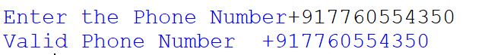

3.Demonstrate use of advanced regular expressions for data validation

import re
reg_no = input("Enter University Register Number: ")
pattern = "^U[0-9]{2}[C][T]\d\d[S]\d\d\d\d" # OR pattern = "U\d\d[C][T]\d\d[S]\d\d\d\d"
result = re.search(pattern, reg_no)
if result:
print("Valid University Register Number:", reg_no)
else:
print("Invalid University Register Number:", reg_no)

Output :
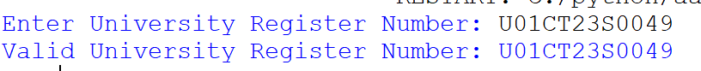

4. Demonstrate use of List

def display_menu():
print("\nMenu:")
print("1. Append an item")
print("2. Remove an item")
print("3. Reverse the list")
print("4. Exit")

def main():
list = []

while True:
display_menu()
c = input("Enter your c (1/2/3/4): ")

if c == '1':
item = input("Enter the item to append: ")
list.append(item)
print(f"Item '{item}' added. Current list: {list}")

elif c == '2':
item = input("Enter the item to remove: ")
if item in list:
list.remove(item)
print(f"Item '{item}' removed. Current list: {list}")
else:
print(f"Item '{item}' not found in the list.")

elif c == '3':
list.reverse()
print(f"List reversed. Current list: {list}")

elif c == '4':
print("Exiting the program.")
break

else:
print("Invalid c. Please try again.")

if __name__ == "__main__":
main()

Output :

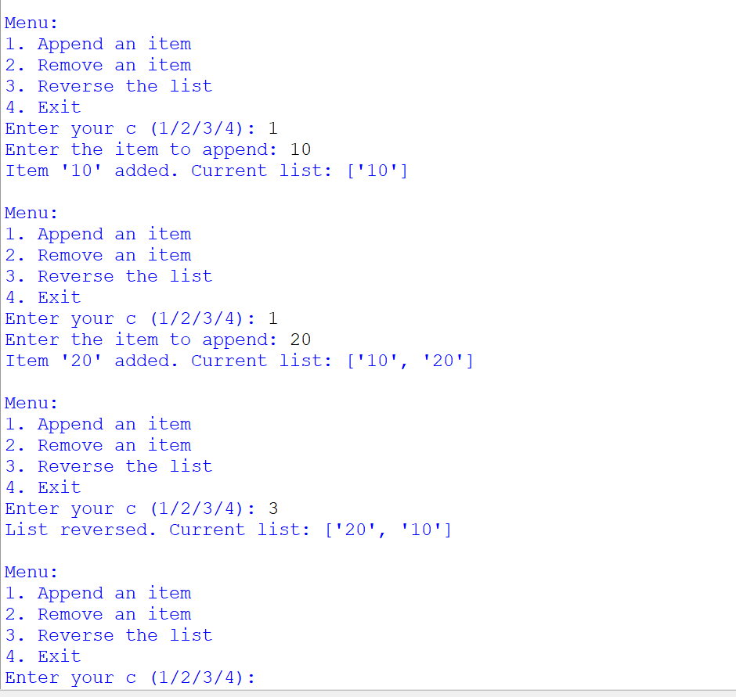

5. Demonstrate use of Dictionaries

def menu():
print("Choose an option:")
print("1. Append")
print("2. Remove")
print("3. Reverse")
print("4. Exit")

def append_item(d):
key = input("Enter the key to append: ")
value = input("Enter the value to append: ")
d[key] = value
print(f"Appended {key}: {value} to dictionary")

def remove_item(d):
key = input("Enter the key to remove: ")
if key in d:
del d[key]
print(f"Removed {key} from dictionary")
else:
print(f"Key '{key}' not found in dictionary")

def reverse_dict(d):
# Reverse the dictionary (keys and values swap)
reversed_dict = {v: k for k, v in d.items()}
print("Reversed dictionary:")
print(reversed_dict)

def main():
my_dict = {}

while True:
menu()
choice = input("Enter your choice (1-4): ")

if choice == '1':
append_item(my_dict)
elif choice == '2':
remove_item(my_dict)
elif choice == '3':
reverse_dict(my_dict)
elif choice == '4':
print("Exiting the program.")
break
else:
print("Invalid choice, please try again.")

if __name__ == "__main__": main()

Output :
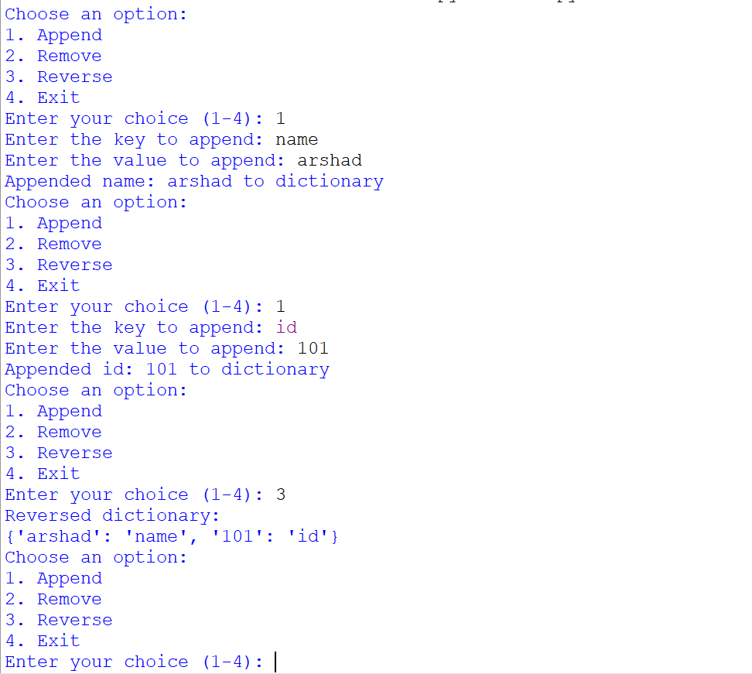

6. Demonstrate Exceptions in Python

try:
output = 5/0
print("I am try Block")
except Exception: # OR ZeroDivisionError
print("Error : cannot divide by 0")
finally:
print("I am Finally")

Output :
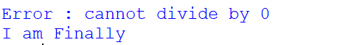

ALL BEST Friends

